January School Day Off
Wizards & Magic Kids Camp
Monday, January 27, 2020
8:30 am – 3:00 pm

What will your children be doing when there is no school on Monday, January 27, 2020? Why not have them join us for a fun day camp? Girl Scout Troop 40333’s day camp for K-5 boys and girls will be led by 9th grade students, who have led at various day camps, including Tillicum Choir Camp, Vasa Park Summer Camp and Girl Scout Summer Camps. This event is a fundraiser for the Troop’s trip to Italy in 2021.
Where: Westminster Chapel, follow signs downstairs to the Middle School Room

13646 NE 24th St
Bellevue, WA 98005
Hours: 8:30 am - 3:00 pm
Cost: Late Registration (starting 1/20) $55/day per camper. Additional siblings are $30
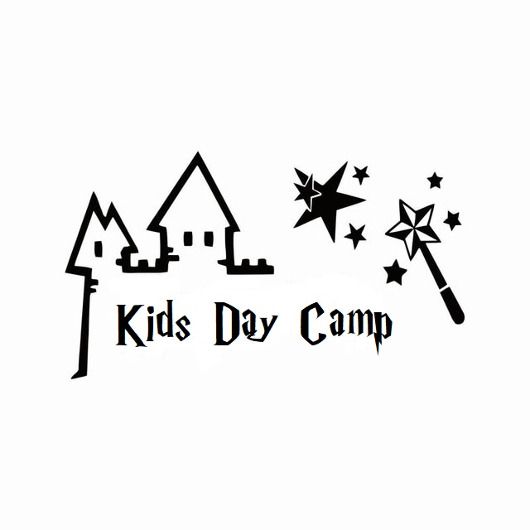
Camp includes: snacks, games, crafts and activities, including card tricks & slime-making!
Lunch: Please make sure to provide a sack lunch and a water bottle for your child. Girl Scouts will provide snacks. For safety, please be sure that all lunch items are nut-free.
Participants should wear close-toed shoes and comfortable clothing.
To register your children, please complete online form:
https://forms.gle/jNpGwzXEDVVev4wg6
Please tell us the following:
- Child’s names:
- Grade:
- If a buddy is attending, first and last name of friend:
Payment may be made online at: http://my-site-101001.square.site/
Or cash/check on the day of the camp for $55/$30. Checks made out to Troop 40333.
If you have questions, please e-mail: girlscout40333@gmail.com

